
Let’s record our improvement story!
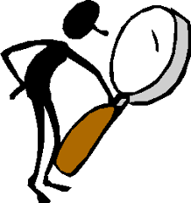

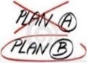
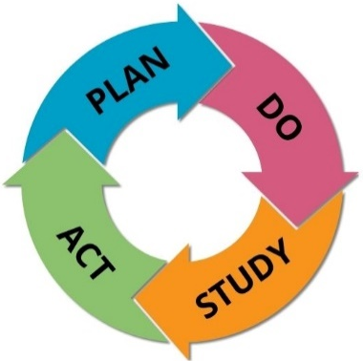


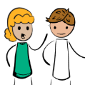
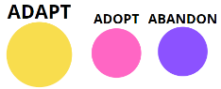
2. DO the experiment/test
- PLAN and PREDICTION
(what we expect might happen)
4. ACT
Choose one thing we will do differently next cycle…

What are we trying to accomplish with this experiment/test?
How will we know the change is an improvement? What will we measure?
what we learned….
3. STUDY -what happened?
Will we

